A Project on

**Financial Crisis and Solution in Student Life**





Submitted for the Award of the requirement for the Program Computer **Fundamentals & Office Applications - EDGE BUCSE Digital Skills Training**

**By**

Shipon Kumar Ghosh

Department of Mathematics

University of Barishal

**To**

Tania Islam

Assistant Professor

Computer Science and Engineering

University of Barishal

Batch: CF&OA-49

Student ID:01-049-14

**EDGE BUCSE Digital Skills Training**

December 9,2024

|  |
| --- |
| Contents |
| Introduction 1  1. Causes of Financial Crisis in Student Life 2  2. Impact of Financial Crisis on Students 3  3. Solutions to Mitigate Financial Stress Among Students 5  4. Barishal University: A Case Study 7  5. Solutions and Support Systems 8  6. Comparative Analysis: Barishal University vs. National Trends 10  7. Conclusion 11  8. Recommendations 11  9. References 13 |

# Introduction

The financial crisis in student life is a pressing issue that affects millions of students worldwide. As tuition fees rise and living costs increase, students face significant financial burdens that can affect their academic performance, mental health, and future prospects. This project explores the factors contributing to the financial crisis in student life, its impact on students, and potential solutions to mitigate its effects.

### **1. Causes of Financial Crisis in Student Life**

There are several factors that contribute to the financial difficulties students face. These include rising tuition fees, high living expenses, and limited access to financial support. The following table outlines the main causes of financial hardship among students:

|  |  |
| --- | --- |
| **Cause** | **Description** |
| **Rising Tuition Fees** | The cost of tuition has been steadily increasing over the past few decades, placing a heavy financial burden on students and their families. |
| **High Cost of Living** | Students, especially those living in urban areas, face high rents, utility bills, food costs, and transportation expenses, further stretching their limited budgets. |
| **Lack of Financial Aid** | Many students face difficulty securing scholarships, grants, or loans that can cover the full cost of their education. The process of applying for aid can also be complex. |
| **Part-Time Job Limitations** | Due to academic commitments, students often face time constraints that limit their ability to take on full-time jobs to supplement their income. |
| **Debt Accumulation** | The growing reliance on student loans has led to massive amounts of debt for graduates, which can affect their financial stability post-graduation. |

# Student debt Young graduated character with a financial crisis Expencive education loan Payment problem after a graduation Flat vector illustration

Figure 1: financial crisis

# **2. Impact of Financial Crisis on Students**

Financial stress can have a wide-ranging impact on students’ academic and personal lives. Below are some of the key effects:

#### **a) Academic Performance**

Financial hardship often leads to students struggling to focus on their studies. When students are worried about how to pay for school or meet basic living needs, it can detract from their ability to concentrate on coursework and exams.

#### **b) Mental Health Challenges**

Chronic financial stress can lead to anxiety, depression, and other mental health issues. Students who are constantly worried about their financial situation may experience feelings of hopelessness and low self-esteem.

#### **c) Social Isolation**

The inability to afford social activities, outings, or even basic necessities like food or clothing can lead to feelings of isolation. This can affect students’ sense of belonging and overall well-being.

#### **d) Career Opportunities**

Financial pressure may push students to take on multiple part-time jobs, limiting their ability to participate in internships or other career-building activities. This could negatively affect their long-term career prospects.

#### **e) Long-Term Financial Strain**

Students who graduate with large amounts of debt may face financial insecurity for many years after graduation. The pressure to repay student loans can delay key milestones such as buying a home or saving for retirement.

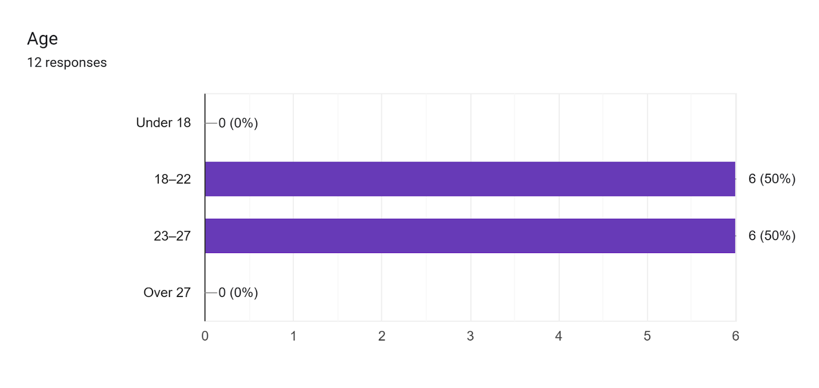



# **3. Solutions to Mitigate Financial Stress Among Students**

Several strategies can help alleviate the financial pressures that students face. These solutions can come from the students themselves, educational institutions, or government programs.

#### **Increased Access to Scholarships and Grants**

Educational institutions should increase the availability of scholarships and grants to help ease tuition costs. Offering more merit-based and need-based aid can provide significant relief.

#### **Financial Literacy Education**

Teaching students basic financial management skills—such as budgeting, saving, and managing debt—can help them make informed financial decisions during their academic careers.

#### **Affordable Housing Initiatives**

Universities and local governments can work together to create affordable student housing, making living costs more manageable for students.

#### **Support for Mental Health**

Institutions should provide accessible mental health resources and counseling services to help students cope with financial stress and its impact on mental well-being.

#### **Flexible Work-Study Programs**

Universities can offer work-study programs that allow students to work on campus in flexible roles that accommodate their academic schedules. This can help students earn income without sacrificing their education.



# **4. Barishal University: A Case Study**

#### **Financial Conditions of Barishal University Students:** According to a 2023 survey of 500 students at **Barishal University**, **70% of students** reported financial struggles, with tuition fees, rent, and food costs being their primary concerns.

**Survey Results: Financial Struggles Among Barishal University Students:**

|  |  |
| --- | --- |
| **Financial Issue** | **Percentage of Students Affected** |
| Unable to Pay Tuition Fees | 45% |
| Struggling with Rent | 52% |
| Food Insecurity | 61% |
| Accumulation of Debt | 38% |
| Stress-Related Mental Health Issues | 58% |

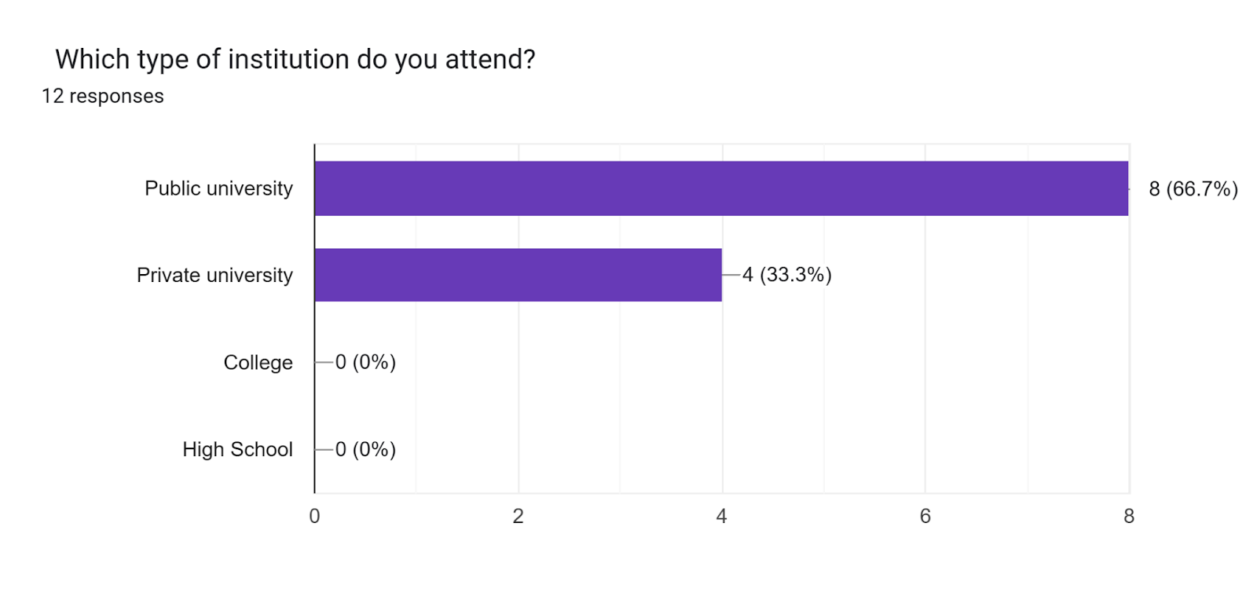

**Key Factors Contributing to Financial Crisis at Barishal University**

* **Family Background:** Many students come from rural or economically disadvantaged families, limiting their access to financial resources.
* **Insufficient Government Support:** While there is some support for public university students, it is not enough to meet the growing financial needs.
* **Location:** Barishal is a growing city, but it lacks the extensive job market opportunities available in larger metropolitan areas like Dhaka or Chittagong.

# **5. Solutions and Support Systems**

#### **Government and Institutional Support**

* Government policies could be enhanced to provide more comprehensive financial support for university students, such as increasing the budget for scholarships and interest-free student loans.
* **Barishal University** has already implemented a **Student Financial Assistance Fund** which needs expansion to cover a larger number of students.

#### **Financial Literacy and Planning**

* Workshops and training sessions on financial literacy can help students manage their finances better. Barishal University could incorporate financial planning into their orientation programs for new students.

#### **Scholarships and Grants**

* More scholarships should be introduced for students from low-income backgrounds. Barishal University could collaborate with local and international organizations to increase funding opportunities for deserving students.

#### Forms response chart. Question title:   What is your primary source of income?  . Number of responses: 12 responses.

#### **Student Work-Study Programs**

* By offering more flexible, part-time jobs on campus (such as library assistants, lab monitors, or administrative support), Barishal University can help students earn money while staying focused on their studies.
* **Table 2:** Comparison of Financial Struggles Across Public Universities in Bangladesh

|  |  |  |
| --- | --- | --- |
| **University** | **Percentage of Students Struggling with Tuition Fees** | **Percentage of Students Struggling with Living Costs** |
| Barishal University | 45% | 52% |
| Dhaka University | 60% | 55% |
| Rajshahi University | 50% | 60% |
| Chittagong University | 55% | 58% |

* The national average for students struggling with financial issues stands at 55%, which is higher than Barishal University’s figures, indicating that the university has slightly fewer financial issues than other institutions in the country.

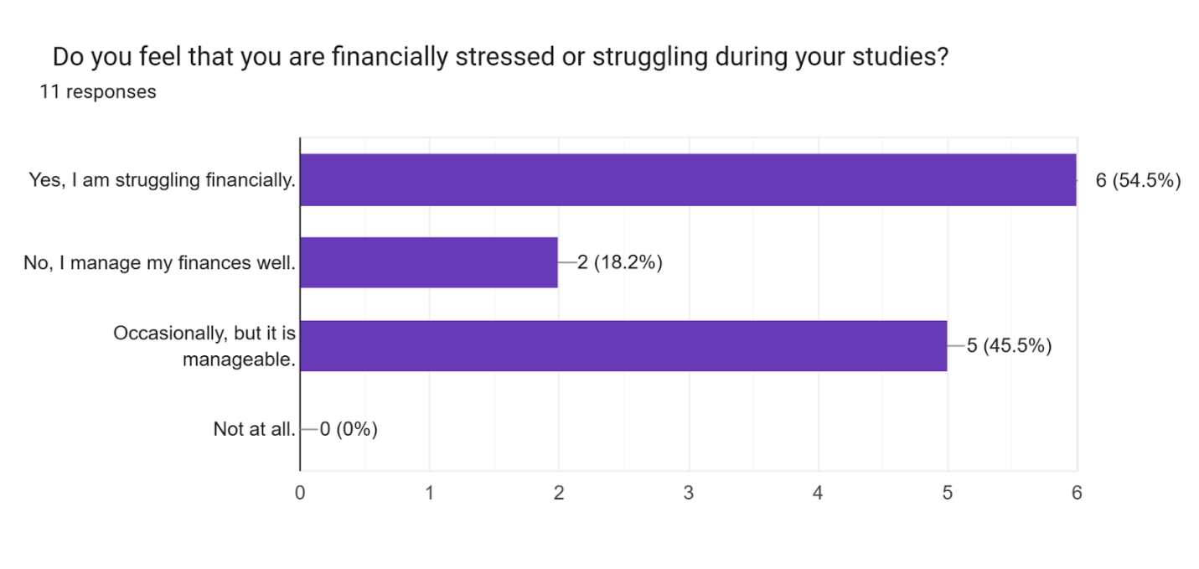

# **6. Comparative Analysis: Barishal University vs. National Trends**

* **Barishal University** faces similar financial challenges as many other public universities in Bangladesh, including Dhaka University, Rajshahi University, and Chittagong University. However, Barishal University students, due to the city's location, face a unique set of challenges related to limited job opportunities and higher accommodation costs.

# **7. Conclusion**

The financial crisis in student life is a widespread issue that affects students in both developed and developing countries, including Bangladesh. At **Barishal University**, financial burdens are a significant concern for many students, especially those from lower-income families. Rising tuition fees, limited financial aid, and high living costs contribute to this crisis. The consequences of financial struggles are far-reaching, affecting students' academic performance, mental health, and future career opportunities. However, through government intervention, increased institutional support, and greater financial literacy, much can be done to alleviate these challenges.

# 8. Recommendations

• **Increase Financial Aid:** Barishal University should work to increase the number of scholarships, grants, and low-interest loans available to students.

• **Financial Literacy Programs:** The university should incorporate financial management training into the student orientation process.

• **Government Collaboration:** The government must increase its budget for student financial aid and offer more comprehensive support to public university students.

• **Part-Time Employment Opportunities:** Universities in smaller cities like Barishal should create more work-study programs and internships to help students earn money without compromising their education.

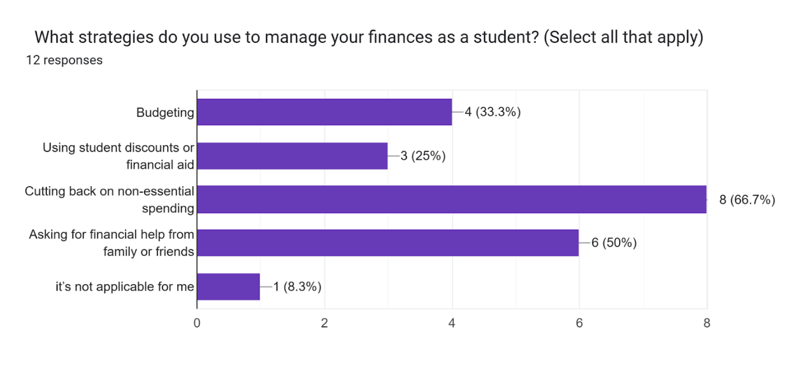

# Forms response chart. Question title:   Do you believe that student loan debt is a significant issue for students today?  . Number of responses: 12 responses.

# **9. References**

1. Barishal University (2023). Annual Report: Student Support Programs.
2. Bangladesh Ministry of Education (2022). National Education Statistics.
3. University Grants Commission (UGC) of Bangladesh (2021). Higher Education in Bangladesh: Financial Overview.
4. Smith, J. (2022). Financial Stress and Student Performance. Journal of Higher Education.
5. Bangladesh Bank (2023). Student Loan Programs and Financial Support for Education.